

**Parking at Zendesk for the April ATD Event**

**Office Address**

25 W. Main St. STE 800

Madison, WI 53703

**Parking Address**

122 W. Doty St.

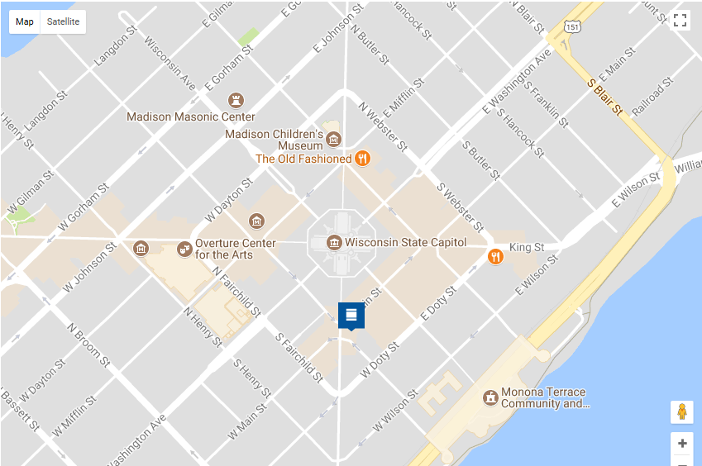

**P**

Parking Lot

**Our parking ramp is located at 122 W. Doty St.** Doty is a one-way street; the entrance will be on your left.

* ENTRANCE LOCATION – The entrance is a block BEFORE you reach the building. The parking garage is under buildings on both sides of Carroll Street. The entrance is under the Pressman building.
* ENTER ON LEFT – Because the entrance is on a one-way street, you enter the ramp on the LEFT SIDE and exit on the RIGHT SIDE. Please see picture below. Please pull a ticket.  Non-reserved spots can be found on levels 2-6.  Level 1 will be reserved for visitor & residential parking.
  + Parking fees are an hourly bases – Zendesk does not validate parking. Ramp is managed by Urban Land Interest (<https://www.uli.com/parking>).
* ELEVATORS – Take Elevators 3 or 4 (see map below) to directly access the 25 W Main St. building lobby. Follow the hallway to the main elevators for access to Zendesk.
  + After 6:00pm and on weekends, you must exit lot through Carroll St. elevators
* If no spaces are available see here for City of Madison parking options <https://www.cityofmadison.com/parking-utility/garages-lots> (street parking is available – but max is 2 hours)

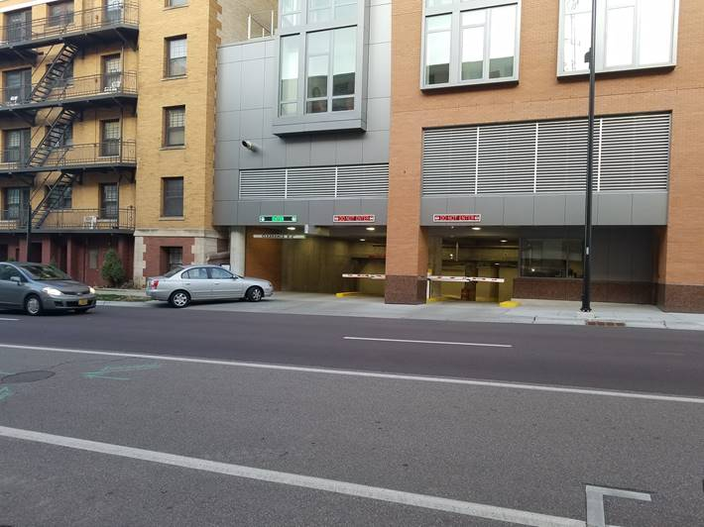

Elevators 3 & 4

Elevator to Carroll St.

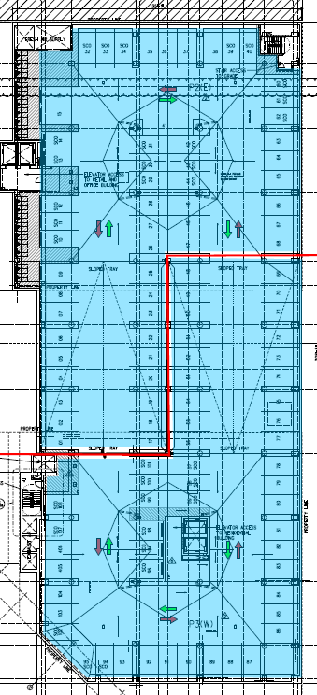

Doty St

Entrance

# Entering the Building from the Main Street

* The entrance is located on Main St. Use the middle set of doors to enter the lobby & elevator area.
* Take the elevator or stairs to the 8th floor (reception).
* For special events, see event signs in lobby for the dedicated floor.

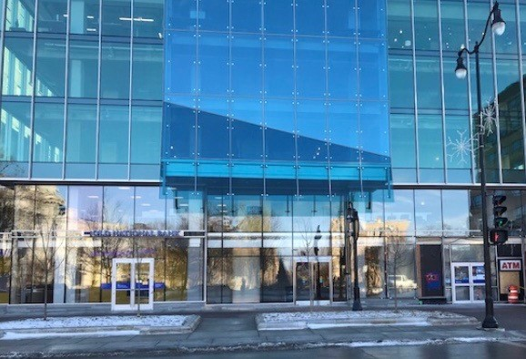

Enter here

the sign once the food is fair am